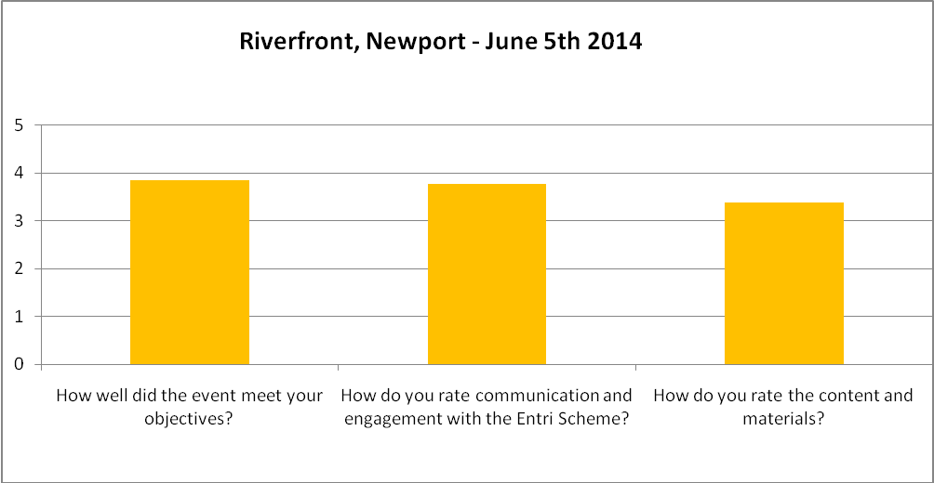Appendix 2: Focus Group Feedback
How well did the event meet your objectives?
- I have a clearer understanding of national scheme although still have practical questions of how the transfer to scheme without losing any elements.
- It was very informative and useful.
- Informative and helped gain understanding on what currently exists and what assistance we as a venue, will receive if we joined the scheme.
- It would have been good to have longer so that we could form break out groups. It would have been easier for more people to contribute.
- All my questions were answered.
- Not clear in terms of information given.
- Very informative.
How do you rate the communication and engagement with the Entri Scheme?
- Bit of a confused event.
- Would be good to have timeline as slide and begin with general overview as there was some confusion amongst group.
- Very clear communication about what the scheme is and where it is going. Sounds good!
- Good to have interpreters but needed two for the afternoon.
- So far, so good. The time between now and Oct ’14 will be paramount to ensure a successful launch.
- Good participation from all.
- Interesting – wonder if it is available nationwide.
How do you rate the contents and materials?
- A list of current criteria would have been useful
- Helpful to be given a handout which gives you he slides along with space to add notes. Informative content.
- Plenty of opportunity for discussion.
- Good. However it would be useful to see actual examples of the schemes application forms and how the venue will manage the application process.
- Clearer slides
- Good – would have been nice to have the presentation beforehand and given copy to the interpreters.
- A clearer background to the existing Cardiff schemes for those unfamiliar would have prevented some confusion.
What parts of the event did you find particularly useful and why?
- Background to widening of the scheme.
- Basic understanding of the thrust and purpose of the proposals.
- Discussions. Good to hear specific customer feedback too. Will make a note to inform arbitrators in advance of big shows going on sale to allow plan of work load.
- Open to ideas, suggestions and happy to answer any questions. Made it feel more engaging and welcoming.
- Emma and Annie were very open to all the ideas thrown at them! Made for a welcoming atmosphere.
- Schedule for future useful.
What parts of the event did you find least useful and why?
- It was all very useful.
- First room was rather small but would have been a useful layout if we were to break into groups and discuss.
- First room was very squashed. The studio space was much better.
- Would like a better idea of timeframe – how it will work for us, contacting customers, rolling it out etc.
- All useful, understood basics.
- Arbitration.
- Change of room was a bit disorientating and the studio wasn’t accessible to wheelchair users/those with mobility requirements.

Would you suggest any improvements to the event?
- Better power point slides.
- Better clarity before arrival (or dealt with in initial information at presentation) and what the entire initiative is about.
- A bit more detail on how the scheme will work (e.g. step by step process, eligibility criteria) earlier on in the presentation, which would answer a lot of the questions posed!
- Needed to be two separate meetings. Groups/venues.
- Yes more clarity needed on existing scheme and proposed future scheme. Need to talk and explain how it effects smaller organisations and across the whole of the industry.
- Clearer outline of: We went out and assessed what happens across the country, we’ve reflected and have decided this is the best way forward, this is the proposal and now is the consultation and the suggested timeline and process.
- Some people I think were very quiet and felt it might have been because venue staff might have been reluctant to talk about what they do in front of disabled people.
- Allowing time to break out into groups in order to discuss and feedback. Helps less confident individuals to get their thoughts across.
- Opportunities for talking in small groups.
- It would be useful to have more concrete examples of how it will work – using New Theatre and WMC as examples.
- Better clarity of what Entri is prior to these kind of events.
- Venue specific sessions.
Do you have any comments?
- October launch feels ambitious but I hope it comes off.
- Would be helpful to understand short, medium and long term aims of the project.
- Local authority access panels/disability panel would be approached o help with arbitration. I think all local authorities have one.
- You need to explain what the scheme is based on i.e. New Theatre and WMC and explain existing criteria. The disabled people in the group seemed very confused by what you are asking them to comment on.
- I think maybe trying smaller group discussions around the criteria may help in people feeling more involved.
- This is a hugely complex scheme, it feels like the tip of the iceberg. It is very much needed but the complexity of peoples access needs raises a lot of issues.
- As a venue who have not actually got a scheme it’s hard to say if the criteria is ‘fair’ or not. Not sure how to measure it.
- Would be a priority to have greater detail on eligibility criteria and short, medium and long term goals.
- Marketing campaign plan for scheme?
If you would be interested in your organisation acting as a regional arbiter please include your full contact details below.
- DAP would like to discuss time, expense etc. of becoming involved in this initiative. Please contact us for discussion.
- Maggie Hampton, Disability Arts Cymru, Sbectrwm, Bwlch Rd, Fairwater, Cardiff, CF5 3EF. Maggie@dacymru.com

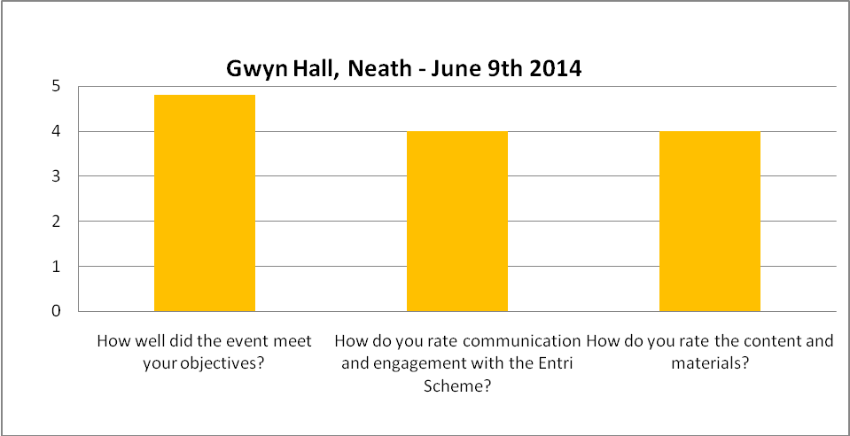

How well did the event meet your objectives?
No comments received
How do you rate the communication and engagement with the Entri Scheme?
- Not sure there was a need to print so much out at such a large size. Understand access requirements but not very environmentally friendly!
- Found it very difficult to hear presentation.
How do you rate the contents and materials?
- Excellent hand out. Good information.
What parts of the event did you find particularly useful and why?
- Networking and generally picking up info.
- All.
- Q&A.
- How the scheme will work – I had a little knowledge of scheme before attending.
What parts of the event did you find least useful and why?
- Acoustics of the room.
Would you suggest any improvements to the event?
- Maybe more explanation of certain terms related to access.
- None
- Please ask venues to label buffets.
- Possibly smaller room in order that participants with hearing difficulties find it easier.
Do you have any comments?
- The timeline for the scheme is very ambitious. From a venue point of view I think more clarity is needed about dealing with hirers and contracts where price and concessions are stipulated. More discussion is needed to make all venues comfortable with signing up.
- Enjoyed the session.
If you would be interested in your organisation acting as a regional arbiter please include your full contact details below.
- None received for this session.

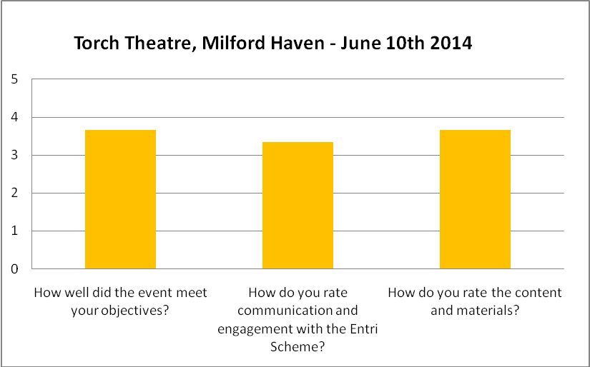

How well did the event meet your objectives?
- Your project, if effective in practice – is stunning
- Informative and thought provoking.
- Wasn’t 100% sure what the event was about.
How do you rate the communication and engagement with the Entri Scheme?
- Engaging discussion instead of absolute dependence on PowerPoint.
- Lack of information beforehand.
- Some areas not really explained well until clarified by the main speakers
- Had no info prior to the day.
How do you rate the contents and materials?
- Concise and informative without waffle.
- Clear and concise.
- Would say there are a lot of things to walk through.
What parts of the event did you find particularly useful and why?
- The open discussion that was encouraged after each section.
- Q&A.
- General discussion was useful.
- All of it.
- Discussions with other visitors.
What parts of the event did you find least useful?
- None.
Would you suggest any improvements to the event?
- More information up front.
- Better explanations and more upfront information.
- Found confusing in parts.
Do you have any comments?
- The entire project and presentation is born out of positivity. Very encouraging and exciting.
- An interesting and informative day.
- Needs more individual venue interaction.
- Concerned about levels of fees and how this may impact on take up.

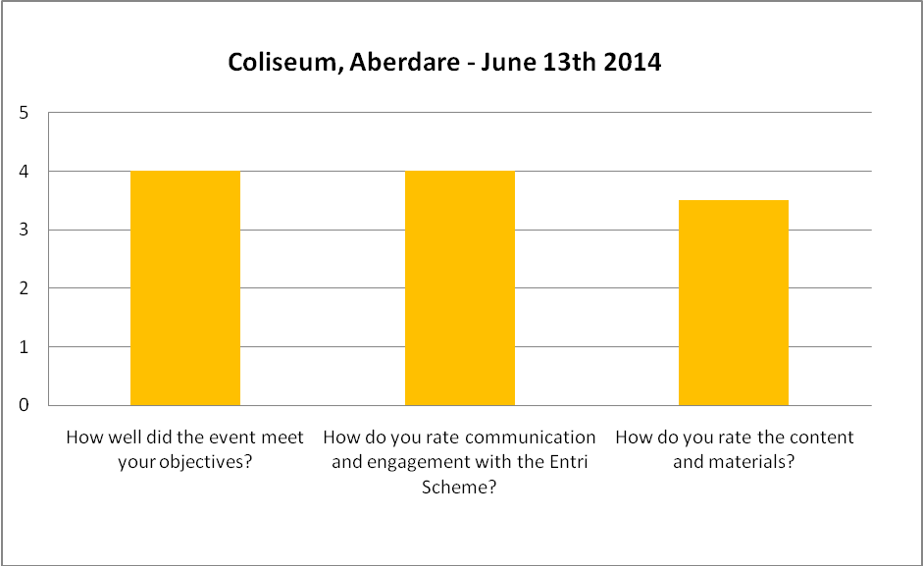
How well did the event meet your objectives?
- Opportunity to understand what is being proposed but was very focused on carers. My interest is primarily deaf/hearing loss audiences and I want to ensure this is prominent in this work.
- Found out more policies for venues.
- I thought the card was also about offering a concession for the disabled patron.
How do you rate the communication and engagement with the Entri Scheme?
- Good to have Diverse Cymru and their expertise and knowledge.
How do you rate the contents and materials?
- Early days – more about discussion and ideas at this stage.
What parts of the event did you find particularly useful and why?
- Sharing Info.
- Policies and procedures. What all other venues are doing.
- Sharing different situations/needs between all stakeholders.
- Discussions on venue – variations/similarities with current policies.
- Learning about our legal requirements.
- Updates on legislation and application.

What parts of the event did you find least useful and why?
- Individual examples do not give a wider picture of the landscape.
Would you suggest any improvements to the event?
- Venue not appropriate – too warm.
- All great.
- Start by introducing what the card is for in detail.
Do you have any comments?
- Excellent session.
- Looking forward to further discussions/logistics info.

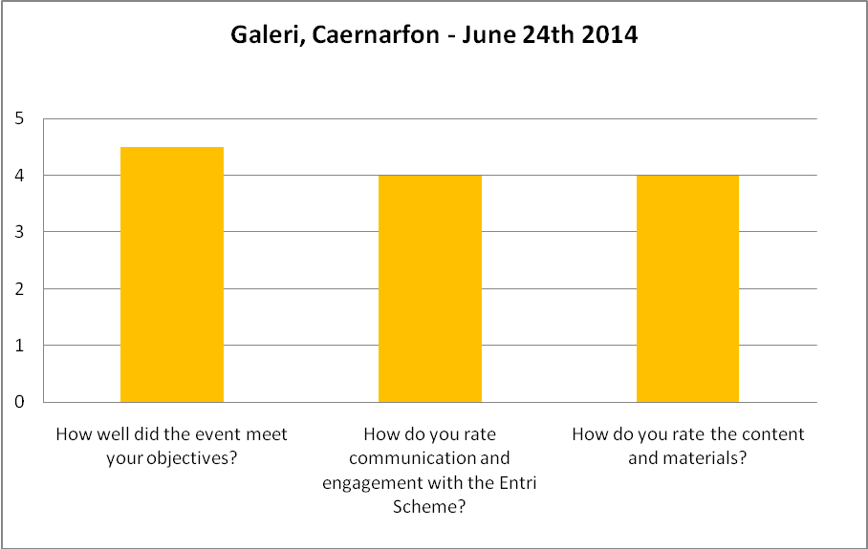

How well did the event meet your objectives?
- Welsh language information of info is welcomed.
- I came to find out. I found out stuff!
- I now have a better understanding of the scheme.
How do you rate the communication and engagement with the Entri Scheme?
- Presenters ‘know their stuff’. Passionate and focused.
- Possible problems engaging with individuals rather than groups.
- Very well presented.
How do you rate the contents and materials?
- Clear and focused agenda. Useful with capacity for writers. Very Good.
- Obvious problem is North Wales with translation, though not a problem for me personally.
- Very informative.
What parts of the event did you find particularly useful and why?
- Booklet for notes with main outline.
- Ability to ask questions throughout the session.
- The introduction.
- Format of meeting is very good, much appreciated. Split between intro and open discussion.
What parts of the event did you find least useful and why?
- Power point – would prefer a booklet. Introduction was not really clear. The Entri Scheme first page relates to theatres and not disabled people. Where is the emphasis?!
Would you suggest any improvements to the event?
- Finding some way of encouraging more disabled individuals to attend.
- Wider involvement with local disability and arts organisations.
- Models of interesting examples of good practise.
Do you have any comments?
- Accessibility clarification – instead of arbitration? Eligibility process?
- I attended the event on behalf of my line manager who was away on holiday, I will pass on the information to him.
- Look forward to Entri going global!

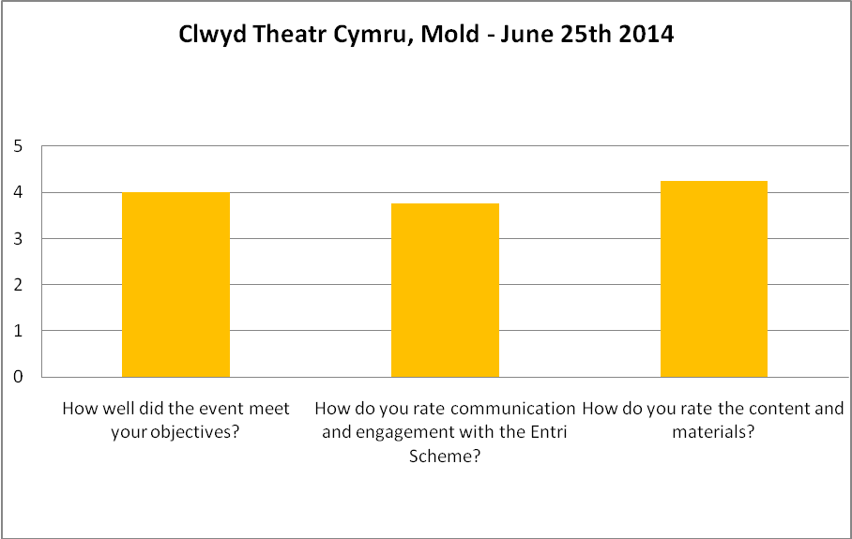

How well did the event meet your objectives?
- Not sure what my objectives were!
- Very informative.
How do you rate the communication and engagement with the Entri Scheme?
- Considering the complexity of the start up in these type of card schemes the team have done a marvellous job pulling the various elements together and communicating these.
- A very worthwhile scheme for parity of access
How do you rate the contents and materials?
- Need to read up more about the scheme.
- Very comprehensive for a preliminary proposal.
What parts of the event did you find particularly useful and why?
- Discussions and networking
- The group discussions – interesting to hear how other venues schemes work.
- Just finding out more.
- Being able to discuss the needs of people with dementia and their families.
- Listening to venue concerns and thoughts. Gives a great understanding of viewpoints to help tailor scope.
- Explanation of how the scheme will work.

What parts of the event did you find least useful and why?
- Housekeeping.
- Not sure.
Would you suggest any improvements to the event?
- Nice to have more people from different organisations.
- I was grossly unprepared as I hadn’t signed up. Would the signing instructions have given information in advance?
- Would have been better to have representatives from carers groups attending and/or disability groups.
Do you have any comments?
- Thought provoking.
- Suggest you engage with local volunteering organisations.

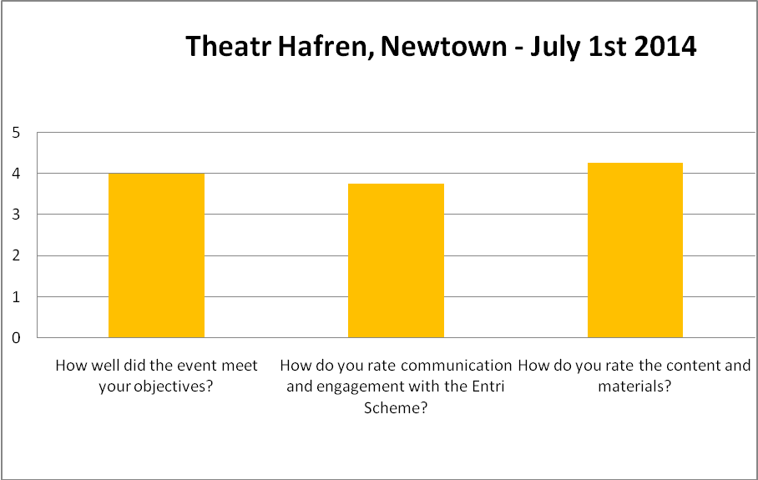

How well did the event meet your objectives?
- Needed clarification of how the scheme would operate and the event was very clear on this.
- As I didn’t really know what I was coming to, the event exceeded my expectations.
- Useful to find out more about the proposed scheme.
How do you rate the communication and engagement with the Entri Scheme?
- Communication was very good and all delegates were engaged to some degree.
How do you rate the contents and materials?
- Very good, well thought out.
What parts of the event did you find particularly useful and why?
- Discussion with other providers.
- I found it all useful – I knew nothing about this before today.
- Gaining a better understanding of the project.
- Discussion/question and answer session
What parts of the event did you find least useful and why?

Would you suggest any improvements to the event?
- Maybe having some information prior to the meeting about the project, to come into practical questions form Box Office – I’m sure they’ll have lots of comments and queries.
Do you have any comments?
- I was sent along as a stand in and I am very pleased that I was!
- Suggestion to look at current percentage of cover seats allocated to work out proportion of total sales and then use that as a basic for charges not turnover.
- Would potentially be interested in the scheme – will have to speak to managers. I like the idea and have had questions answered sufficiently.

